Case Study1: Implementing a Scalable Data Management System Using Java and MongoDB

Background
A growing e-commerce company faced challenges in managing and scaling its rapidly increasing data volumes. The company's existing relational database struggled to handle the high traffic and complex queries associated with their expanding user base. To address these issues, the company decided to migrate to a NoSQL database system, specifically MongoDB, due to its scalability, flexibility, and ease of integration with Java, the primary programming language used by their development team.

Objective
The main objectives of the migration were to:
- Improve Performance: Handle large volumes of unstructured and semi-structured data efficiently.
- Enhance Scalability: Support horizontal scaling to accommodate the growing number of users and transactions.
- Simplify Data Modeling: Leverage MongoDB’s flexible schema design to simplify the representation of complex data structures.
- Seamless Integration: Ensure smooth integration with existing Java-based microservices and applications.

System Architecture
The architecture of the new system involved transitioning from a monolithic application to a microservices architecture, with MongoDB as the central data store. The key components included:
- Java Microservices: Independent services for managing different aspects of the e-commerce platform, such as user accounts, product catalogs, and orders.
- MongoDB Cluster: A sharded MongoDB cluster to ensure high availability, fault tolerance, and horizontal scaling.
- Java MongoDB Driver: Java applications used the MongoDB Java driver to interact with the database, performing CRUD operations, indexing, and querying.

Implementation
- Data Modeling: The first step was to design the data models in MongoDB, taking advantage of its flexible schema. The following collections were created:
  - Users: To store user profiles, authentication data, and preferences.
  - Products: To store product details, categories, and pricing information.
  - Orders: To manage order histories, transaction details, and shipping information.
Each collection used documents to represent data, allowing nested structures and arrays, which were difficult to manage in the previous relational database.

Example of a product document:
{
"_id": ObjectId("6123abcd4567ef8901234567"),
"name": "Wireless Headphones",
"category": "Electronics",
"price": 99.99,
"stock": 150,
"features": ["Bluetooth", "Noise Cancelling", "12-hour Battery Life"],
"reviews": [
{
"user_id": ObjectId("6123abcd4567ef8901234568"),
"rating": 5,
"comment": "Great sound quality!"
}
]
}
- Setting Up MongoDB Cluster: A sharded MongoDB cluster was set up to distribute data across multiple nodes, ensuring load balancing and fault tolerance. The cluster consisted of:
  - Config Servers: To manage metadata and configuration settings for the cluster.
  - Shard Servers: To store the data, each shard containing a subset of the database.
  - Mongos Router: To route client requests to the appropriate shard.
- Java Integration: The development team integrated MongoDB with Java using the MongoDB Java driver. This involved configuring the connection to the MongoDB cluster and performing database operations.
Example Java code for connecting to MongoDB and inserting a document:
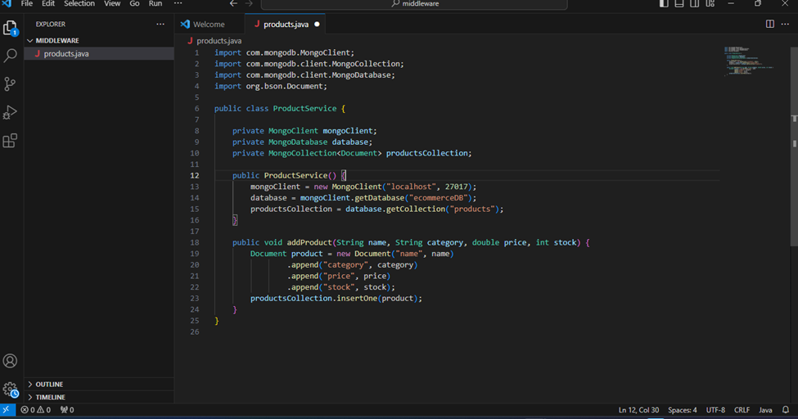

- Migration and Testing: Data from the existing relational database was migrated to MongoDB using ETL (Extract, Transform, Load) tools. The migrated data was validated through extensive testing to ensure consistency and correctness. Load testing was also conducted to measure the performance improvements and scalability.
- Deploying Microservices: The Java microservices were deployed in a cloud environment using containers (Docker) and orchestrated with Kubernetes. This setup allowed for easy scaling and management of services.

Challenges and Solutions
- Data Migration: Migrating data from a relational database to MongoDB required careful planning. Data transformation scripts were written to handle the conversion of relational data to MongoDB’s document-based structure. ETL tools were also used to automate parts of the migration process.
- Query Optimization: As MongoDB uses a different query language and indexing strategy than traditional relational databases, the team had to optimize queries and indexes to ensure fast retrieval of data, especially for complex queries involving multiple fields.
- Scalability Management: Initially, there were challenges with managing the shards and ensuring even distribution of data. This was addressed by fine-tuning the sharding key and monitoring the cluster’s performance closely.

Results
The migration to MongoDB resulted in significant improvements in the system’s performance and scalability:
- Improved Query Performance: Queries that previously took seconds to execute were reduced to milliseconds, thanks to MongoDB’s indexing and efficient query processing.
- Scalability: The system could easily scale horizontally by adding more nodes to the MongoDB cluster, ensuring it could handle increasing traffic and data volumes.
- Simplified Data Management: MongoDB’s flexible schema allowed the company to easily manage and evolve its data models without the constraints of a fixed schema.

Conclusion
The implementation of MongoDB, integrated with Java microservices, provided the e-commerce company with a scalable and high-performance solution for managing its growing data needs. The case study highlights the effectiveness of MongoDB in handling large volumes of unstructured data and the ease with which it can be integrated into existing Java-based systems. The successful migration to MongoDB not only improved system performance but also positioned the company for future growth and expansion.

2: Implementing a Distributed Application using Java RMI

Background
In the early 2000s, a financial services company faced the challenge of integrating multiple systems across different geographical locations. The company operated with various branches, each running separate applications on different servers. The need arose to develop a distributed application that could allow seamless communication and data sharing across these branches in real-time. Java RMI was chosen as the technology to solve this problem due to its ability to support distributed object computing and remote method invocation across different servers.

Objective
The primary objective was to design and implement a distributed application that could:
- Allow remote method invocation for shared services across different servers.
- Enable real-time data synchronization between branch offices.
- Ensure secure and efficient communication over the network.
- Be scalable to accommodate the growing number of branches.

System Architecture
The architecture was based on a client-server model where different branch offices acted as clients, and a central server managed shared resources. The main components included:
- Server Application: Hosted the business logic and managed shared resources. It was responsible for handling remote method calls from clients.
- Client Application: Deployed at each branch office, this application could invoke methods on the server application remotely to perform operations such as querying account balances, processing transactions, and updating customer records.
- RMI Registry: A naming service where server objects were registered and clients could look up these objects using a known name.

Implementation
- Designing the Remote Interface: The first step was to define a remote interface that declared the methods available for remote invocation. For example:
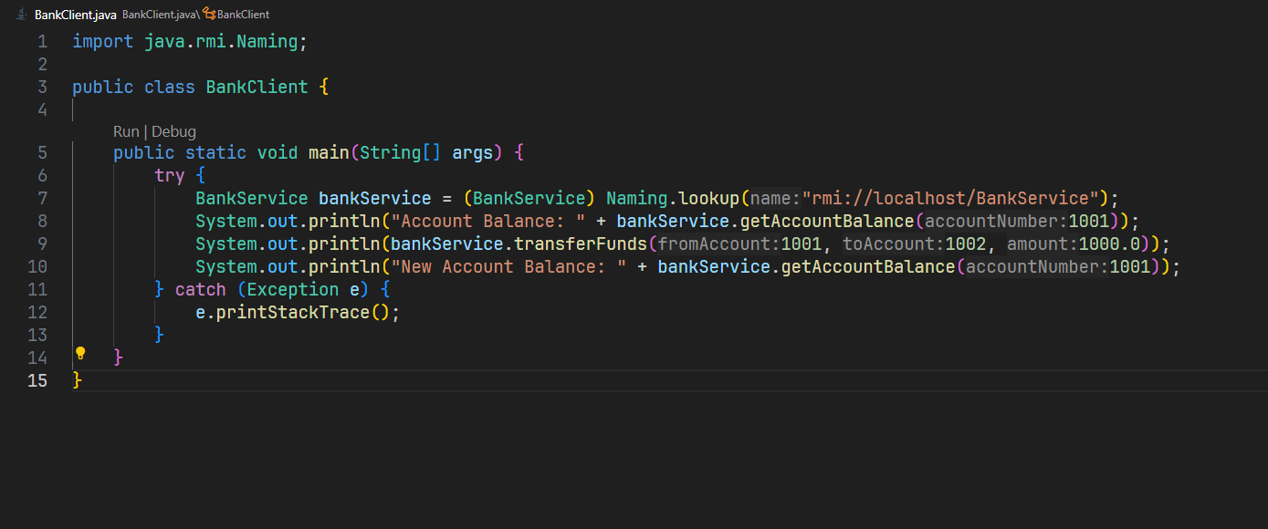
- Implementing the Remote Object: The server-side class implemented the remote interface and provided the business logic.
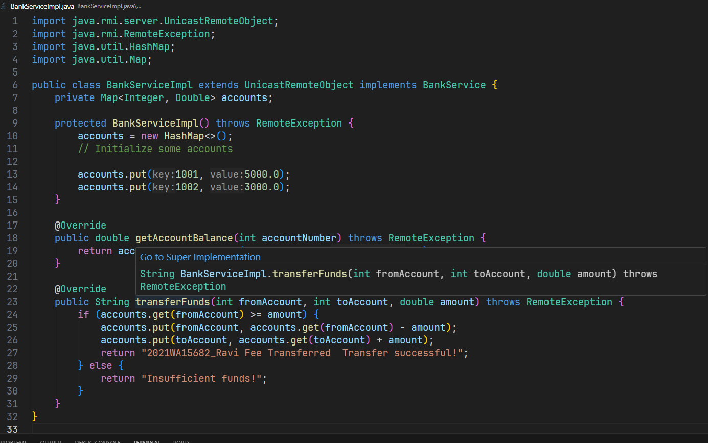
- Starting the RMI Server: The server application instantiated the remote object and registered it with the RMI registry.
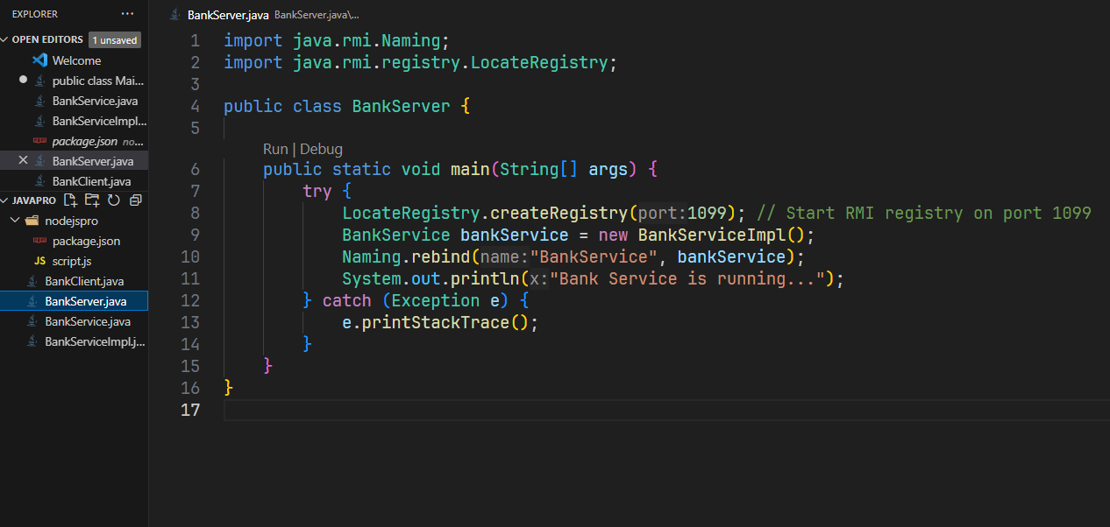
- Developing the Client Application: The client-side application looked up the remote object in the RMI registry and invoked its methods. 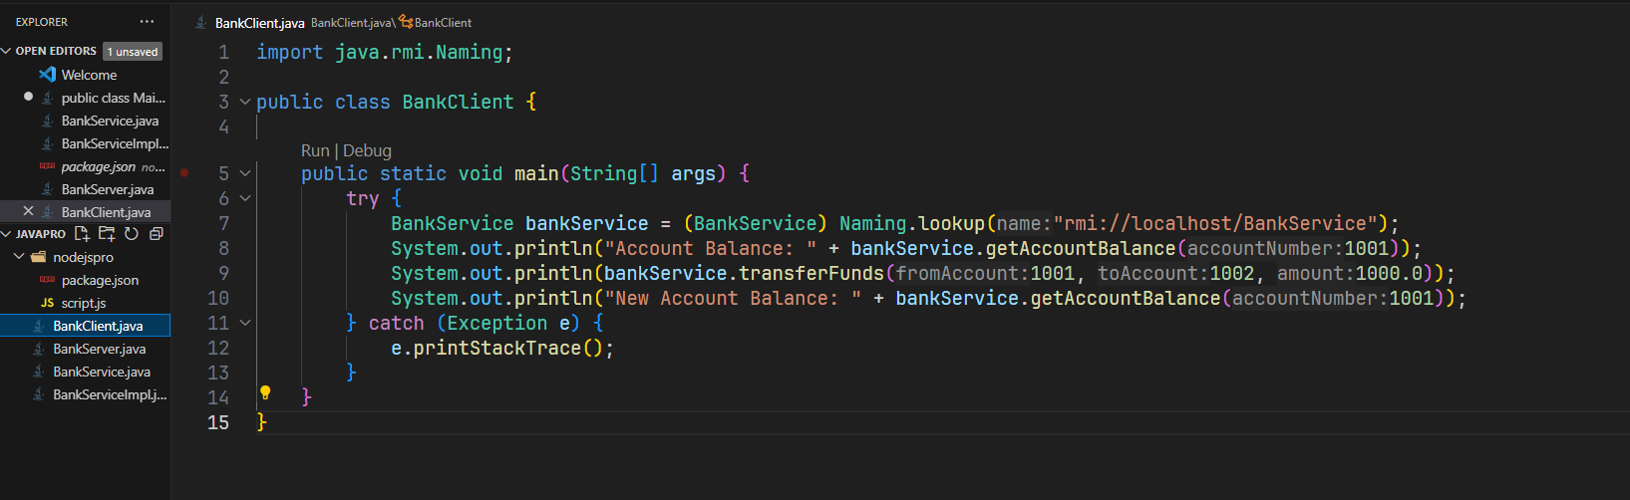

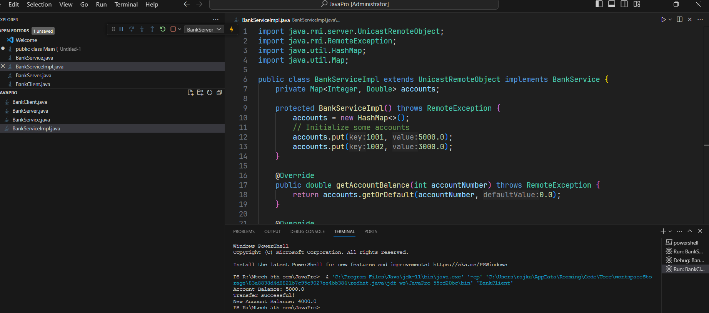

Challenges and Solutions
- Network Latency and Security: As the RMI system relied on network communication, latency was a concern. The solution involved optimizing the network infrastructure and applying secure communication protocols using SSL for RMI connections.
- Scalability: To ensure scalability, load balancing strategies were implemented. The system was designed to distribute client requests across multiple servers using a round-robin approach.
- Error Handling: The system had to handle network failures gracefully. This was achieved by implementing robust exception handling and automatic retries for failed remote method invocations.

Results
The Java RMI-based distributed application successfully met the company’s needs. It provided real-time data synchronization, seamless remote method invocation, and improved operational efficiency across multiple branches. The system was scalable, secure, and could handle a growing number of remote clients without significant performance degradation.

Conclusion
Java RMI proved to be a reliable and effective solution for building distributed applications that require remote method invocation. Its ease of use, combined with Java’s built-in security features, made it an ideal choice for the financial services company’s needs. The case study demonstrates how Java RMI can be applied in real-world scenarios to solve complex distributed computing challenges.

3. Try a different example of Restful application (I have shared an example after doing the demo during the CS)
This time for managing a collection of products in an online store:
const express = require('express');
const Joi = require('joi');
const app = express();
app.use(express.json());

// Sample data: List of products
const products = [
{ name: 'Laptop', id: 1, price: 1000 },
{ name: 'Smartphone', id: 2, price: 700 },
{ name: 'Tablet', id: 3, price: 400 },
{ name: 'Headphones', id: 4, price: 150 },
{ name: 'Smartwatch', id: 5, price: 200 },
{ name: 'Monitor', id: 6, price: 300 },
{ name: 'Keyboard', id: 7, price: 50 }
];

// Read Request Handlers
app.get('/', (req, res) => {
res.send('Welcome to the Online Store REST API!');
});

// Display the list of all products
app.get('/api/products', (req, res) => {
res.send(products);
});

// Display information of a specific product by ID
app.get('/api/products/:id', (req, res) => {
const product = products.find(p => p.id === parseInt(req.params.id));
if (!product) return res.status(404).send('<h2 style="font-family: Malgun Gothic; color: darkred;">Product not found!</h2>');
res.send(product);
});

// CREATE Request Handler
app.post('/api/products', (req, res) => {
// Validation logic could be added here
const product = {
id: products.length + 1,
name: req.body.name,
price: req.body.price
};
products.push(product);
res.send(product);
});

// Update Request Handler
app.put('/api/products/:id', (req, res) => {
const product = products.find(p => p.id === parseInt(req.params.id));
if (!product) return res.status(404).send('<h2 style="font-family: Malgun Gothic; color: darkred;">Product not found!</h2>');

product.name = req.body.name;
product.price = req.body.price;
res.send(product);
});

// Delete Request Handler
// Remove a product from the collection by ID
app.delete('/api/products/:id', (req, res) => {
const product = products.find(p => p.id === parseInt(req.params.id));
if (!product) return res.status(404).send('<h2 style="font-family: Malgun Gothic; color: darkred;">Product not found!</h2>');

const index = products.indexOf(product);
products.splice(index, 1);
res.send(product);
});

// Validate function (optional, could be used in POST and PUT)
function validateProduct(product) {
const schema = {
name: Joi.string().min(3).required(),
price: Joi.number().required()
};
return Joi.validate(product, schema);
}

// PORT ENVIRONMENT VARIABLE
const port = process.env.PORT || 8080;
app.listen(port, () => console.log(`Listening on port ${port}...`));

Key Differences:
- Context: This script is designed to manage a collection of products in an online store.
- Sample Data: The products array includes product names, IDs, and prices.
- Endpoints: The URLs and variable names reflect the product context, making it suitable for an online store's product management system.

4) Create a collection using Mongodb and perform the CRUD operations
Here's an example of how to create a MongoDB collection and perform basic CRUD (Create, Read, Update, Delete) operations using Node.js and the mongodb package.

Step 1: Install MongoDB and the mongodb Node.js Driver
First, make sure you have MongoDB installed and running on your machine. Then, install the mongodb package using npm:
npm install mongodb

Step 2: Create a Node.js Script for CRUD Operations
Below is a script that demonstrates how to create a MongoDB collection and perform CRUD operations:
const { MongoClient } = require('mongodb');

// Connection URL
const url = 'mongodb://localhost:27017';
const client = new MongoClient(url);

// Database Name
const dbName = 'onlineStore';

// Connect to the MongoDB server
async function main() {
await client.connect();
console.log('Connected successfully to server');
const db = client.db(dbName);
const collection = db.collection('products');

const insertResult = await collection.insertMany([
{ name: 'Laptop', price: 1000, stock: 50 },
{ name: 'Smartphone', price: 700, stock: 100 },
{ name: 'Tablet', price: 400, stock: 200 }
]);
console.log('Inserted documents:', insertResult.insertedCount);

// READ: Find one document
const findOneResult = await collection.findOne({ name: 'Laptop' });
console.log('Found one document:', findOneResult);

// READ: Find all documents
const findResult = await collection.find({}).toArray();
console.log('Found documents:', findResult);

//UPDATE: Update a document
const updateResult = await collection.updateOne({ name: 'Laptop' }, { $set: { price: 1200 } });
console.log('Updated documents:', updateResult.modifiedCount);

// DELETE: Delete a document
const deleteResult = await collection.deleteOne({ name: 'Tablet' });
console.log('Deleted documents:', deleteResult.deletedCount);

return 'CRUD operations completed';
}

// Run the main function and catch errors
main()
.then(console.log)
.catch(console.error)
.finally(() => client.close());

Step 3: Running the Script
To run the script, save it to a file (e.g., mongodb_crud.js) and execute it using Node.js:
node mongodb_crud.js

Explanation of the Code:
- Connection to MongoDB:
  - The MongoClient connects to the MongoDB server using the provided URL.
- Database and Collection:
  - The dbName specifies the database (onlineStore), and the collection is named products.
- CRUD Operations:
  - Create: The script inserts multiple documents into the products collection.
  - Read: It retrieves documents from the collection using findOne (for a single document) and find (for multiple documents).
  - Update: The script updates the price of a product (Laptop) using the updateOne method.
  - Delete: It deletes a document (Tablet) from the collection using the deleteOne method.
- Closing the Connection:
  - The script ends by closing the connection to the MongoDB server with client.close().

Output
When you run the script, it will display output similar to:
Connected successfully to server
Inserted documents: 3
Found one document: { _id: ..., name: 'Laptop', price: 1000, stock: 50 }
Found documents: [ { _id: ..., name: 'Laptop', price: 1000, stock: 50 }, ... ]
Updated documents: 1
Deleted documents: 1
CRUD operations completed
This example demonstrates a basic implementation of CRUD operations using MongoDB in a Node.js environment.

